https://github.com/KingsGambitLab/Lecture_Notes/blob/non-dsa/Academy%20DSA%20Typed%20Notes/Java%20Refresher/Refresher%202D%20Arrays.md
Revision Notes for Scaler Live Class on Matrix Operations
Introduction
In this class, we focused on performing various operations on matrices. The fundamental topics included calculating the sum of rows, finding the maximum element in columns, and implementing a wave print of the matrix. Below are detailed notes on each of the concepts covered:
1. Calculating Row-wise Sum
To calculate the sum of each row in a matrix and print the result:
- Initialize the sum variable for each row individually to avoid accumulation of sums from previous rows.
- Iterate through each row using a nested loop structure:
  - The outer loop iterates over each row.
  - The inner loop iterates through each column of the current row and accumulates the sum.
- Print the sum after completing the iteration for each row.
Detailed Example
Given matrix:
3 4
5 6
- Sum for row 0: 3 + 4 = 7
- Sum for row 1: 5 + 6 = 11
PseudoCode
public static void printRowSum(int[][] matrix) {
int numberOfRows = matrix.length;
int numberOfColumns = matrix[0].length;

for (int row = 0; row < numberOfRows; row++) {
int sum = 0; // Reset sum for each row
for (int col = 0; col < numberOfColumns; col++) {
sum += matrix[row][col];
}
System.out.println(sum);
}
}
2. Calculating the Sum of All Elements in the Matrix
To find the sum of all elements in the matrix:
- Initialize a total sum variable.
- Iterate through every element in the matrix.
- Accumulate the sum in the total sum variable.
- Print the total sum.
Example
Given matrix:
1 2
3 4
- Total sum: 1 + 2 + 3 + 4 = 10
PseudoCode
public static int sumMatrix(int[][] matrix) {
int totalSum = 0;
for (int row = 0; row < matrix.length; row++) {
for (int col = 0; col < matrix[row].length; col++) {
totalSum += matrix[row][col];
}
}
return totalSum;
}
3. Finding the Column-wise Maximum
To find the maximum value in each column:
- Initialize the max variable to the smallest integer value (or the first element of the column).
- Iterate through each column using nested loops:
  - The outer loop iterates over each column.
  - The inner loop iterates over each row of the current column to find the max value.
- Update and track the maximum value for each column.
- Print the maximum value of each column.
Example
Given matrix:
1 3 -2 7
9 0 8 -1
5 6 -2 3
- Max of columns: [9, 6, 8, 7]
PseudoCode
public static int[] findColumnMax(int[][] matrix) {
int numberOfRows = matrix.length;
int numberOfColumns = matrix[0].length;
int[] maxValues = new int[numberOfColumns];

for (int col = 0; col < numberOfColumns; col++) {
int max = Integer.MIN_VALUE; // Or matrix[0][col]
for (int row = 0; row < numberOfRows; row++) {
if (matrix[row][col] > max) {
max = matrix[row][col];
}
}
maxValues[col] = max;
}
return maxValues;
}
4. Waveform Printing of the Matrix
To print a matrix in a wave-like fashion:
- Iterate through each row with the outer loop.
- Print elements from left to right for even-indexed rows.
- Print elements from right to left for odd-indexed rows.
Example
Given matrix:
1 3 -2 7
9 0 8 -1
5 6 -2 3
3 4 0 2
- Output:
1 3 -2 7
-1 8 0 9
5 6 -2 3
2 0 4 3
PseudoCode
public static void wavePrintMatrix(int[][] matrix) {
int numberOfRows = matrix.length;
int numberOfColumns = matrix[0].length;

for (int row = 0; row < numberOfRows; row++) {
if (row % 2 == 0) {
// Print left to right
for (int col = 0; col < numberOfColumns; col++) {
System.out.print(matrix[row][col] + " ");
}
} else {
// Print right to left
for (int col = numberOfColumns - 1; col >= 0; col--) {
System.out.print(matrix[row][col] + " ");
}
}
System.out.println();
}
}
Summary
These operations cover essential matrix handling techniques that can be useful for numerous programming challenges and real-world data handling. Practicing these will strengthen your understanding of nested loops and problem-solving with 2D arrays.
For more detailed explanations and examples, refer to the notes taken during the class.
INDEXING IN ARRAYS:
Convert one-based indexing to zero-based indexing for array positions.

ARRAY INITIALIZATION:
Create an array of size n+1 if anticipating insertion of additional elements.
ELEMENT INSERTION:
Shift elements to right to insert a new element at a specific position in an array.

ROW-WISE SUM:
Calculate and print the sum of each row in a 2D array.

COLUMN-WISE SUM:
Sum of all elements in each column returned in an array.

COLUMN-WISE MAXIMUM:
Find and print the maximum value in each column of 2D array.

2D ARRAYS:
A 2D array is an array of arrays, used to represent a matrix.

MATRIX INITIALIZATION:
Create a matrix and populate it by taking input row by row.

MATRIX TRAVERSAL:
Iterate through a matrix either by row or column by column for various operations.

MATRIX SUM:
Compute the sum of all elements in a matrix.

WAVEFORM PRINTING:
Print matrix rows as is for even rows and in reverse for odd rows.

STRING CONCATENATION:
Use the plus operator to concatenate string or a string with an integer.

LEFTMOST COLUMN PRINT:
Print all values of the leftmost column in a matrix.

LEFTMOST COLUMN:
The first column of a matrix from top to bottom.

TOP ROW:
The first row of matrix from left to right.

MATRIX INPUT:
Taking matrix input row in a 2D array.

LOOP IN MATRIX:
Nested loops used for iterating over a matrix.

TOP LEFT CORNER:
The matrix element at row 0 and column 0.

BOTTOM RIGHT CORNER:
The matrix element at row n-1 and column m-1.

MATRIX DIMENTIONS:
Defined by the number of rows and columns.

FREQUENCY COUNT:
Process of counting the occurrence of each element in an array.

MATRIX TRANSPOSE:
Flipping a matrix over its diagonal, swapping rows with columns.

ARRAY SEARCHING:
Checking if a certain element exits in an array using iteration.

STRICTLY INCREAING ARRAY:
Array where each element is smaller than the next one, ensuring a consistent increase.

INVERSE OF ARRAY:
Switching elements and their indices in a given array.

ROW BY ROW MATRIX PRINT:
Printing each row of a matrix sequentially from top to bottom.

SORTEDNESS CHECK:
Verifying if an array is sorted in a specific order, like ascending or descending.

DIAGONAL MATRIX FLIP:
Reversing the order of rows or columns to alter the matrix while maintaining structural integrity.

Revision Notes on 2D Arrays
Introduction to 2D Arrays
Definition
- A 2D array is a data structure that stores elements in a grid format or matrix. It has both rows and columns, which can be thought of as having both length and breadth【8:5†source】.
Comparison with 1D Arrays
- While a 1D array is essentially a line with a single dimension or length, a 2D array is like a rectangle with two dimensions—a grid【8:2†source】.
Real-Time Applications
- Real-life examples of 2D arrays include:
  - Chessboards
  - Theatre seating layouts
  - Tic-Tac-Toe grids
  - LED screens (pixels are arranged in 2D)
  - Egg trays【8:2†source】【8:3†source】.
Basic Operations on 2D Arrays
Creation and Initialization
- The syntax for creating a 2D array in Java:
- int[][] matrix = new int[3][4];
Here, [3] is the number of rows, and [4] is the number of columns【8:3†source】.
Accessing Elements
- Example of accessing an element at the 1st row and 2nd column:
- matrix[1][2];
- Each element of a 2D array can be accessed by specifying its row and column indices【8:9†source】【8:14†source】.
Printing 2D Arrays
- Row-wise Printing: For printing elements row by row, loop through each row and print all its columns【8:5†source】.
- Column-wise Printing: Similarly, for column-wise printing, loop through each column and print all its rows【8:12†source】.
- Waveform Printing: This involves printing even indexed rows left to right and odd indexed rows right to left, effectively creating a zigzag pattern【8:13†source】.
Common Operations
Row-wise Sum
- Compute the sum of elements in each row and return an array containing these sums.
- int sum[] = new int[n];
- for(int row=0; row<n; row++){
- int total = 0;
- for(int column=0; column<m; column++){
- total += matrix[row][column];
- }
- sum[row] = total;
- }
- total is reset for each row to ensure correct sum calculation【8:4†source】【8:9†source】.
Column-wise Maximum
- Find the maximum value for each column and return them as an array.
- int max[] = new int[m];
- for(int column=0; column<m; column++){
- int maximum = matrix[0][column];
- for(int row=0; row<n; row++){
- if(matrix[row][column] > maximum)
- maximum = matrix[row][column];
- }
- max[column] = maximum;
- }
- Start by assuming the first element in each column is the maximum initially【8:7†source】【8:18†source】.
Additional Considerations
Looping Constructs
- Nested Loops: Essential for iterating through a 2D array, typically using one loop for rows and another nested one for columns【8:12†source】.
Example Problems
- Printing the Top Row: Loop through the columns of the first row.
- Printing the Leftmost Column: Loop through the rows of the first column【8:15†source】【8:10†source】.
Key Points to Remember
- Always initialize accumulators like sum inside the appropriate loop to avoid cumulative errors.
- Indexing starts from 0; hence, adjust loop bounds accordingly【8:4†source】【8:16†source】.
This set of notes consolidates the essential concepts about handling 2D arrays, including their structure, usage, initialization, and manipulation techniques, as discussed in the recent class.

Here's a comprehensive set of revision notes based on the live class transcript. These notes are structured to facilitate easy understanding and revision of the topics discussed during the class.

Class Revision Notes
Introduction
The class started with a brief revisitation of some concepts and problems from the previous sessions. Assignments were discussed, and students were encouraged to solve them attentively while participating in the quizzes. The instructor emphasized understanding problem statements before diving into solutions.
Key Concepts Discussed
1. Searching in Arrays
Problem: Is an Element Present?
- Objective: Given an array and an integer k, determine if k is present in the array.
- Approach: Loop through the array, checking each element to see if it equals k. If a match is found, return true (or print it); otherwise, return false after the loop.
- Technique Used: Basic iteration through the array using a for-loop .
2. Finding Frequency in Arrays
Problem: Frequency of an Element
- Objective: Find how many times a specific element appears in an array.
- Approach: Iterate through the array, maintaining a count of the occurrences of the specified element.
- Code: Implemented using a simple loop and conditional check to increment a counter each time the target element is found .
Problem: Frequency Count of All Elements
- Objective: For each element in the array, determine its frequency and store these frequencies in a corresponding array.
- Approach: Use a nested loop structure. For each element, check the entire array to count occurrences and store results in an "answer" array.
- Efficiency Discussion: The given solution involves repeating operations, which is not the most efficient. The instructor highlighted that efficiency concerns, such as using a hash map for optimization, would be covered in later classes .
3. Matrix Operations
Row-wise Sum
- Objective: Given an N x M matrix, calculate the sum of elements for each row.
- Implementation: Iterate through each row, sum the elements, and store the result in an array corresponding to each row.
- Output Format: Return an array where each index corresponds to the sum of the elements in that row .
Column-wise Max
- Objective: Determine the maximum element in each column of a matrix and store these in an array.
- Approach: Iterate through each column, then sub-loop through each row to determine the maximum for that column .
4. Matrix Transpose
- Concept Overview: Transposing a matrix involves swapping rows with columns. For an element at position [i][j] in matrix A, it moves to position [j][i] in the transposed matrix B.
- Process: The instructor demonstrated the transpose via practical examples, explaining how the first column turns into the first row and so forth .
5. Strictly Increasing Array
- Problem: Check if an array is in strictly increasing order.
- Approach: Traverse the array and ensure each element is less than the succeeding element. Return true if this condition holds throughout the array; otherwise, return false.
- Code Snippet: Use a simple loop with a condition check. This was emphasized as a crucial exercise for understanding ordered data .
Practice and Assignments
- Students were encouraged to implement the discussed problems, including additional practice via homework problems—such as calculating column-wise operations and experimenting with modifying arrays.
Conclusion
The class concluded with a focus on accuracy of code and cultivating a habit of writing clean, readable programs. It was also emphasized that while efficiency is crucial, initial learning should focus on understanding correctness and developing coding skills .

This revision should serve as a comprehensive guide to understanding the discussed concepts. For further clarification of any concept, reviewing the class recordings or related material is recommended.

2D ARRAY CLASS:

Array is the sequential collection of similar items.
e.g., tic tac toe game, chess, graphs, cricket stadium light.

Syntax:
int[][] arr=new int[row size][column size];

int[][] mat=new int[3][5]; total 15 elements

mat [0][0] | mat [0][1] | mat [0][2] | mat [0][3] | mat [0][4]
mat [1][0] | mat [1][1] | mat [1][2] | mat [1][3] | mat [1][4]
mat [2][0] | mat [2][1] | mat [2][2] | mat [2][3] | mat [2][4]

Top left=0,0
Top right=0,m-1
Bottom left=n-1,0
Bottom right=n-1,m-1

Q. Create array of 5 col and 7 rows

Int[][] arr= new int[7][5];

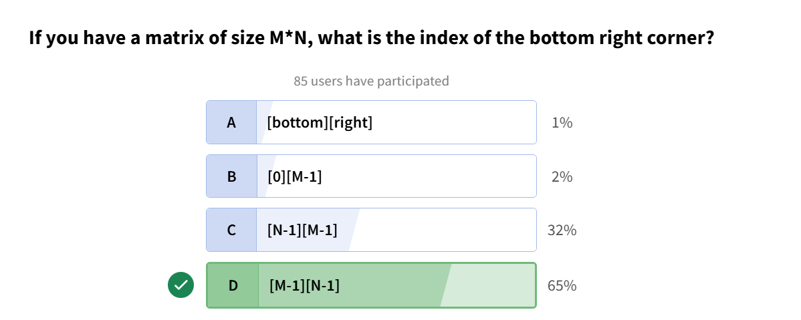
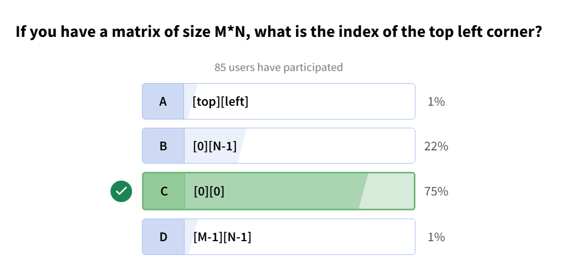
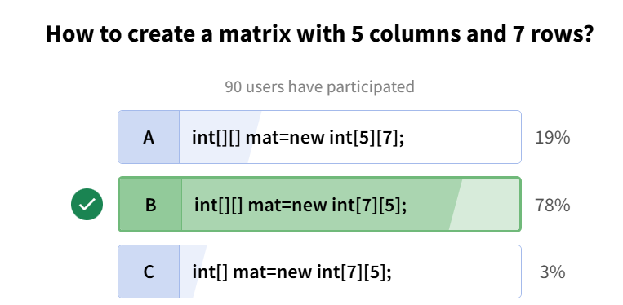
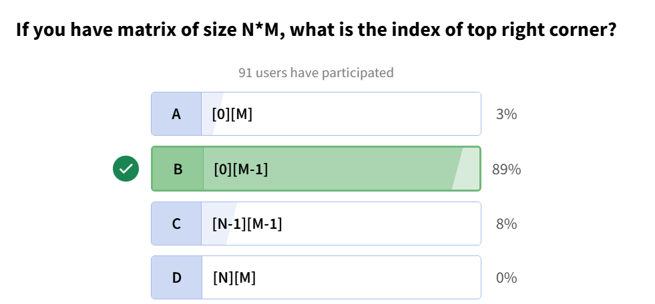
Q. Given matrix of size NxM , print its top row;
import java.util.*;
public class Main {
public static void main(String[] args) {
int[][] arr={{1,2,3},{4,5,6},{7,8,9}};
for(int i=0;i<arr[0].length;i++){
System.out.println(arr[0][i]);
}
}
}
OUTPUT:
1
2
3
Q. Given matrix of size NxM , print its left most column;
import java.util.*;
public class Main {
public static void main(String[] args) {
int[][] arr={{1,2,3},{4,5,6},{7,8,9}};
for(int i=0;i<arr.length;i++){
System.out.println(arr[i][0]);
}
}
}
OUTPUT:
1
4
7
Q. Given matrix of size NxM , print row by row;
import java.util.*;
public class Main {
public static void main(String[] args) {
int[][] arr={{1,2,3},{4,5,6},{7,8,9}};
for(int i=0;i<arr.length;i++){
for(int j=0;j<arr[i].length;j++){
System.out.print(arr[i][j]+" ");
}
System.out.println();
}
}
}
OUTPUT:
1 2 3
4 5 6
7 8 9
Q. Given matrix of size NxM , print column by column;
import java.util.*;
public class Main {
public static void main(String[] args) {
int[][] arr={{1,2,3},{4,5,6},{7,8,9}};
for(int i=0;i<arr.length;i++){
for(int j=0;j<arr[i].length;j++){
System.out.print(arr[j][i]+" ");
}
System.out.println();
}
}
}
OUTPUT:
1 4 7
2 5 8
3 6 9
Q. return some of given matrix
import java.util.*;
public class Main {
public static void main(String[] args) {
int[][] arr={{1,2,3},{4,5,6},{7,8,9}};
int sum=0;
for(int i=0;i<arr.length;i++){
for(int j=0;j<arr[i].length;j++){
sum+=arr[j][i];
}
}
System.out.print(sum);
}
}
OUTPUT:
45
Q. print matrix in waveform
e.g.,
if matrix is:
1 2 3
4 5 6
7 8 9

Waveform of above matrix is:
1 2 3
6 5 4
7 8 9
CODE:
import java.util.*;
public class Main {
public static void main(String[] args) {
int[][] arr={{1,2,3},{4,5,6},{7,8,9}};
for(int i=0;i<arr.length;i++){
if(i%2==0)
for(int j=0;j<arr[i].length;j++){
System.out.print(arr[i][j]+" ");
}
else
for(int j=arr[i].length-1;j>=0;j--){
System.out.print(arr[i][j]+" ");
}
System.out.println();
}
}
}

OUTPUT:
1 2 3
6 5 4
7 8 9
Q. for given matrix return row wise sum in array form
import java.util.*;
public class Main {
public static void main(String[] args) {
int[][] arr={{1,2,3},{4,5,6},{7,8,9}};
int[] newArr=new int[arr[0].length];
for(int i=0;i<arr.length;i++){
int sum=0;
for(int j=0;j<arr[i].length;j++){
sum+=arr[i][j];
}
newArr[i]=sum;
}
System.out.print(Arrays.toString(newArr));
}
}
OUTPUT:
[6, 15, 24]
Q. for given matrix return column wise sum in array form
import java.util.*;
public class Main {
public static void main(String[] args) {
int[][] arr={{1,2,3},{4,5,6},{7,8,9}};
int[] newArr=new int[arr[0].length];
for(int i=0;i<arr.length;i++){
int sum=0;
for(int j=0;j<arr[i].length;j++){
sum+=arr[j][i];
}
newArr[i]=sum;
}
System.out.print(Arrays.toString(newArr));
}
}
OUTPUT:
[12, 15, 18]
Q1. Print matrix row by row
Problem Description
Given a matrix of N rows and M columns, print it row by row. Firstly print 0th row, then 1st row, 2nd row and so on.
Problem Constraints
1 <= N <= 100
1 <= M <= 100
1 <= mat[i][j] <= 10000
Input Format
Two values denoting N and M,
Next N lines contain M space separated integers representing the matrix Mat
Output Format
N lines denoting each row.
Note: Ensure there is a space character (' ') at the end of the line.
Example Input
3 4
10 20 30 40
50 60 70 80
90 100 110 120
Example Output
10 20 30 40
50 60 70 80
90 100 110 120
Example Explanation
0th row -> 10 20 30 40
1st row -> 50 60 70 80
2nd row -> 90 100 110 120
CODE:
import java.lang.*;
import java.util.*;

public class Main {
public static void main(String[] args) {
Scanner ip=new Scanner(System.in);
int row=ip.nextInt();
int col=ip.nextInt();
for(int i=0;i<row;i++){
for(int j=0;j<col;j++){
System.out.print(ip.nextInt()+" ");
}
System.out.println();
}
}
}
CODE2:
import java.lang.*;
import java.util.*;

public class Main {
public static void main(String[] args) {
Scanner sc=new Scanner(System.in);
byte N=sc.nextByte(),M=sc.nextByte();
int[][] mat=new int[N][M];
for(int i=0;i<N;i++){
for(int j=0;j<M;j++) {
mat[i][j]=sc.nextInt();
System.out.print(mat[i][j]+" ");
}
System.out.println();
}
}
}
Q2. Wave Print (Column Wise)
Problem Description
Write a program to input an integer N and a N*N matrix Mat from user and print the matrix in wave form (column wise)
See example for clarifications regarding wave print.
Note: Ensure there is a space character (' ') at the end of the line.
Problem Constraints
1 <= N <= 10³
0 <= Mat[i][j] <= 10⁹
Input Format
First line is an integer N
Next N lines contain N space separated integers representing the matrix Mat
Output Format
A single line containing N*N integers of matrix Mat in wave form (column wise)
Example Input
Input 1:
3
4 1 2
7 4 4
3 7 4
Input 2:
2
1 2
3 4
Example Output
Output 1:
4 7 3 7 4 1 2 4 4
Output 2:
1 3 4 2
Example Explanation
For Input 1:
We will first iterate the 1st column from top to bottom and print the elements,
then we will iterate the 2nd column from botton to top and print the elements,
then we will iterate the 3rd column from top to bottom and print the elements.
For Input 2:
We will first iterate the 1st column from top to bottom and print the elements,
then we will iterate the 2nd column from bottom to top and print the elements.
CODE:
import java.lang.*;
import java.util.*;

public class Main {
public static void main(String[] args) {
Scanner ip=new Scanner(System.in);
int mat=ip.nextInt();
int[][] arr=new int[mat][mat];
for(int i=0;i<mat;i++){
for(int j=0;j<mat;j++){
arr[i][j]=ip.nextInt();
}
}
for(int i=0;i<mat;i++){
if(i%2==0)
for(int j=0;j<mat;j++){
System.out.print(arr[j][i]+" ");
}
else
for(int j=mat-1;j>=0;j--){
System.out.print(arr[j][i]+" ");
}
}
}
}
Q3. Wave Print (Row Wise)
Problem Description
Given an N x N matrix, print the elements of the matrix in a wave form row-wise. For the first row, traverse from left to right, for the second row, traverse from right to left, and continue this alternating pattern for the remaining rows.
Problem Constraints
1 <= N <= 10³
0 <= Mat[i][j] <= 10⁹
Input Format
First line is an integer N
Next N lines contain N space separated integers representing the matrix Mat
Output Format
A single line containing N*N integers of matrix Mat in wave form (row wise)
Note: Ensure there is a space character (' ') at the end of the line.
Example Input
Input 1:
3
4 1 2
7 4 4
3 7 4
Input 2:
2
1 2
3 4
Example Output
Output 1:
4 1 2 4 4 7 3 7 4
Output 2:
1 2 4 3
Example Explanation
For Input 1:
We will first iterate the 1st row from left to right and print the elements,
then we will iterate the 2nd row from right to left and print the elements,
then we will iterate the 3rd row from left to right and print the elements.
This looks like a wave.
For Input 2:
We will first iterate the 1st row from left to right and print the elements,
then we will iterate the 2nd row from right to left and print the elements.
This looks like a wave.
CODE:
import java.lang.*;
import java.util.*;

public class Main {
public static void main(String[] args) {
Scanner ip=new Scanner(System.in);
int mat=ip.nextInt();
int[][] arr=new int[mat][mat];
for(int i=0;i<mat;i++){
for(int j=0;j<mat;j++){
arr[i][j]=ip.nextInt();
}
}
for(int i=0;i<mat;i++){
if(i%2==0)
for(int j=0;j<mat;j++){
System.out.print(arr[i][j]+" ");
}
else
for(int j=mat-1;j>=0;j--){
System.out.print(arr[i][j]+" ");
}
}
}
}

Q4. Print sum of every Row
Problem Description
Write a program to input an N X M matrix A from user and print sum of every row.
Problem Constraints
1 <= N <= 100
1 <= M <= 100
1 <= A[i][j] <= 10000
Input Format
Two values denoting N and M,
Next N lines contain M space separated integers representing the matrix A.
Output Format
Print sum of each row space separated.
Example Input
3 4
1 2 3 4
5 6 7 8
9 2 4 1
Example Output
10 26 16
Example Explanation
0th row sum -> 1+2+3+4 = 10
1st row sum -> 5+6+7+8 = 26
2nd row sum-> 9+2+4+1 = 16
CODE:
import java.lang.*;
import java.util.*;

public class Main {
public static void main(String[] args) {
Scanner ip=new Scanner(System.in);
int row=ip.nextInt(),col=ip.nextInt();
for(int i=0;i<row;i++){
int sum=0;
for(int j=0;j<col;j++){
sum+=ip.nextInt();
}
System.out.print(sum+" ");
}
}
}
CODE2:
import java.lang.*;
import java.util.*;

public class Main {
public static int[] sumOfRow(int[][] mat){
int[] sum=new int[mat.length];
for(int i=0;i<mat.length;i++){
sum[i]=0;
for(int j=0;j<mat[0].length;j++) sum[i]+=mat[i][j];
}
return sum;
}
public static void print(int[][] mat){
int[] sum=sumOfRow(mat);
for(int i=0;i<sum.length;i++) System.out.print(sum[i]+" ");
}
public static void main(String[] args) {
Scanner sc=new Scanner(System.in);
int N=sc.nextInt(),M=sc.nextInt();
int[][] arr=new int[N][M];
for(int i=0;i<N;i++) for(int j=0;j<M;j++) arr[i][j]=sc.nextInt();
print(arr);
}
}
Q5. Add the matrices
Problem Description
You are given two matrices A & B of same size, you have to return another matrix which is the sum of A and B.
Note: Matrices are of same size means the number of rows and number of columns of both matrices are equal.
The Following will give you an idea of matrix addition:
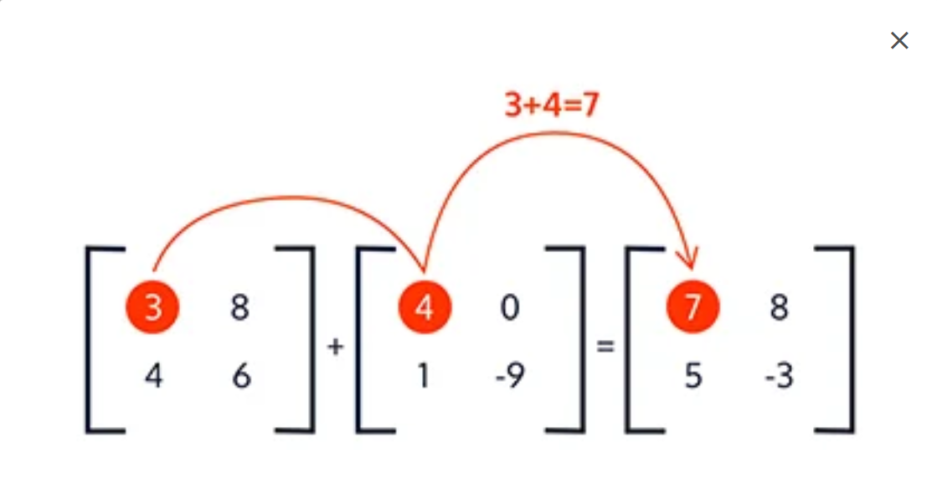
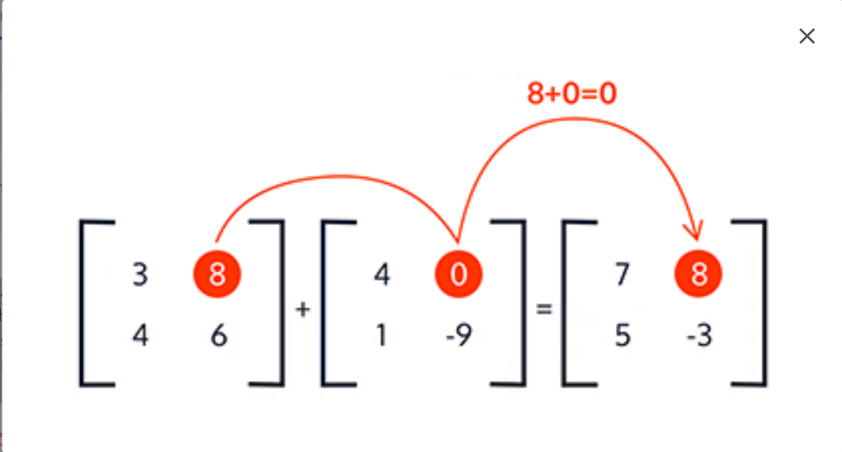
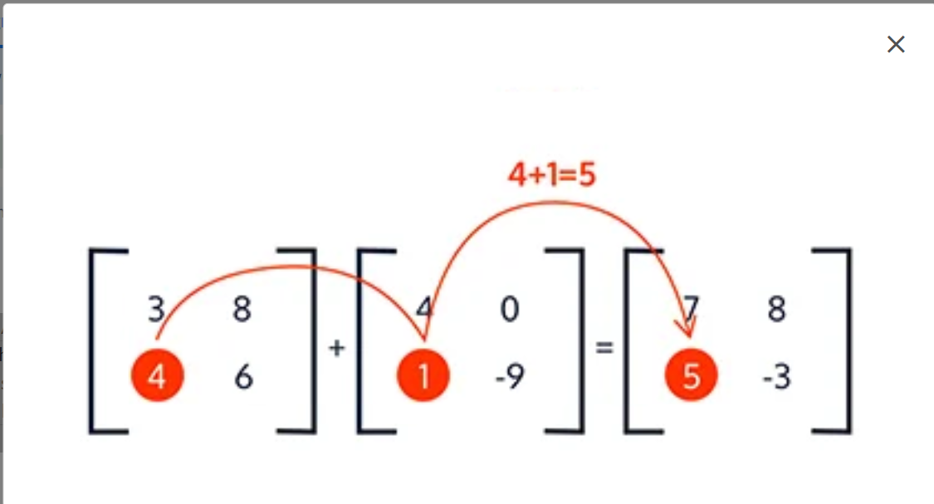
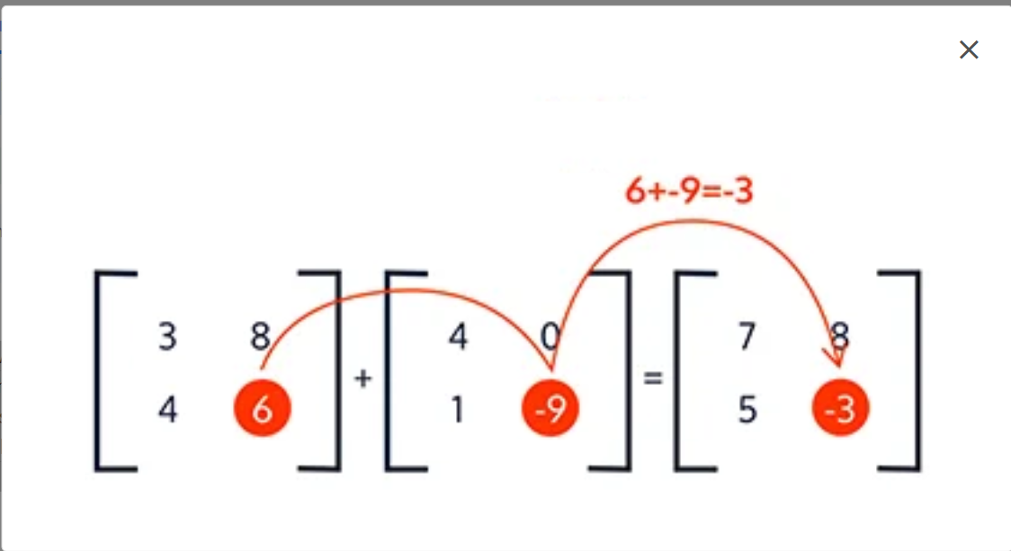
Problem Constraints
1 <= A.size(), B.size() <= 1000 1 <= A[i].size(), B[i].size() <= 1000 1 <= A[i][j], B[i][j] <= 1000
Input Format
The first argument is the 2D integer array A The second argument is the 2D integer array B
Output Format
You have to return a vector of vector of integers after doing required operations.
Example Input
Input 1:
A = [[1, 2, 3],
[4, 5, 6],
[7, 8, 9]]
B = [[9, 8, 7],
[6, 5, 4],
[3, 2, 1]]
Input 2:
A = [[1, 2, 3],
[4, 1, 2],
[7, 8, 9]]
B = [[9, 9, 7],
[1, 2, 4],
[4, 6, 3]]
Example Output
Output 1:
[[10, 10, 10],
[10, 10, 10],
[10, 10, 10]]
Output 2:
[[10, 11, 10],
[5, 3, 6],
[11, 14, 12]]
Example Explanation
Explanation 1:
A + B = [[1+9, 2+8, 3+7],
[4+6, 5+5, 6+4],
[7+3, 8+2, 9+1]]
= [[10, 10, 10],
[10, 10, 10],
[10, 10, 10]].
Explanation 2:
A + B = [[1+9, 2+9, 3+7],
[4+1, 1+2, 2+4],
[7+4, 8+6, 9+3]]
= [[10, 11, 10],
[5, 3, 6],
[11, 14, 12]].
CODE:
public class Solution {
public int[][] solve(int[][] A, int[][] B) {
int[][] res=new int[A.length][A[0].length];
for(int i=0;i<A.length;i++){
for(int j=0;j<A[0].length;j++){
res[i][j]=A[i][j]+B[i][j];
}
}
return res;
}
}
CODE2:
public class Solution {
public ArrayList<ArrayList<Integer>> solve(ArrayList<ArrayList<Integer>> A, ArrayList<ArrayList<Integer>> B) {
ArrayList<ArrayList<Integer>> finalRes=new ArrayList<>();
for(int i=0;i<A.size();i++){
ArrayList<Integer> res=new ArrayList<Integer>();
for(int j=0;j<A.get(0).size();j++){
res.add(A.get(i).get(j)+B.get(i).get(j));
}
finalRes.add(res);
}
return finalRes;
}
}

Q1. Sum of Columns of 2D Array
Problem Description
Given a 2D integer array C[][] of A rows and B columns. Return an integer array of size B that represents the sums of the columns of the 2D array C.
Problem Constraints
1 <= A,B <= 10³
1 <= C[i][j] <= 10³
Input Format
The first argument is a single integer A.
The second argument is a single integer B.
The third argument is a 2D integer array C.
Output Format
Return an integer array of size B that represents the sums of the columns of the 2D array C.
Example Input
Input 1:
A = 3
B = 2
C = [[4, 1], [1, 3], [6, 2]]
Input 2:
A = 2
B = 2
C = [[1, 1], [4, 1]]
Example Output
Output 1:
[11, 6]
Output 2:
[5, 2]
Example Explanation
Explanation 1:
Column 1 : 4 + 1 + 6 = 11
Column 2 : 1 + 3 + 2 = 6
Explanation 2:
Column 1 : 4 + 1 = 5
Column 2 : 1 + 1 = 2
CODE:
public class Solution {
public int[] solve(int A, int B, int[][] C) {
int[] sum=new int[B];
for(int i=0;i<B;i++) {
sum[i]=0;
for(int j=0;j<A;j++){
sum[i]+=C[j][i];
}
}
return sum;
}
}
CODE2:
import java.util.ArrayList;
import java.util.Collections;

public class Solution {
public ArrayList<Integer> solve(int A, int B, ArrayList<ArrayList<Integer>> C) {
// initialize result with B zeros
ArrayList<Integer> colSums = new ArrayList<>(Collections.nCopies(B, 0));
if (C == null) return colSums;

for (int i = 0; i < A && i < C.size(); i++) {
ArrayList<Integer> row = C.get(i);
if (row == null) continue;
// only iterate up to B and the actual row length (handles ragged arrays)
for (int j = 0; j < B && j < row.size(); j++) {
colSums.set(j, colSums.get(j) + row.get(j));
}
}
return colSums;
}
}
Q2. Largest in each Row of 2D Array
Problem Description
Given a 2D array A of N rows and M columns. Find value of largest element in each row.
Problem Constraints
1 <= N, M <= 1000
1 <= A_{i} <= 10⁹
Input Format
The first argument A is a 2D array of integers
Output Format
Return an array of length N, in which every index i contains the maximun value of the i_{th} row in the 2D matrix.
Example Input
Input 1:
A = [[1, 2], [1, 3]]
Input 2:
A = [[1, 2, 3]]
Example Output
Output 1:
[2, 3]
Output 2:
[3]
Example Explanation
Explanation 1:
In the first row 2 is maximum value.
In the second row 3 is maximum value.
Explanation 2:
In the first and only row 3 is maximum value.
CODE:
public class Solution {
public int[] solve(int[][] A) {
int[] large=new int[A.length];
for(int i=0;i<A.length;i++){
large[i]=Integer.MIN_VALUE;
for(int j=0;j<A[0].length;j++){
if(A[i][j]>large[i]) large[i]= A[i][j];
}

}
return large;
}
}
Q3. Matrix Subtraction
Problem Description
You are given two integer matrices A and B having same size(Both having same number of rows (N) and columns (M). You have to subtract matrix B from A and return the resultant matrix. (i.e. return the matrix A - B).
If A and B are two matrices of the same order (same dimensions). Then A - B is a matrix of the same order as A and B and its elements are obtained by doing an element wise subtraction of A from B.
Problem Constraints
1 <= N, M <= 10³
-10⁹ <= A[i][j], B[i][j] <= 10⁹
Input Format
The first argument is the 2D integer array A
The second argument is the 2D integer array B
Output Format
Return a 2D matrix denoting A - B.
Example Input
Input 1:
A = [[1, 2, 3],
[4, 5, 6],
[7, 8, 9]]
B = [[9, 8, 7],
[6, 5, 4],
[3, 2, 1]]
Input 2:
A = [[1, 1]]
B = [[2, 3]]
Example Output
Output 1:
[[-8, -6, -4],
[-2, 0, 2],
[4, 6, 8]]
Output 2:
[[-1, -2]]
Example Explanation
Explanation 1:
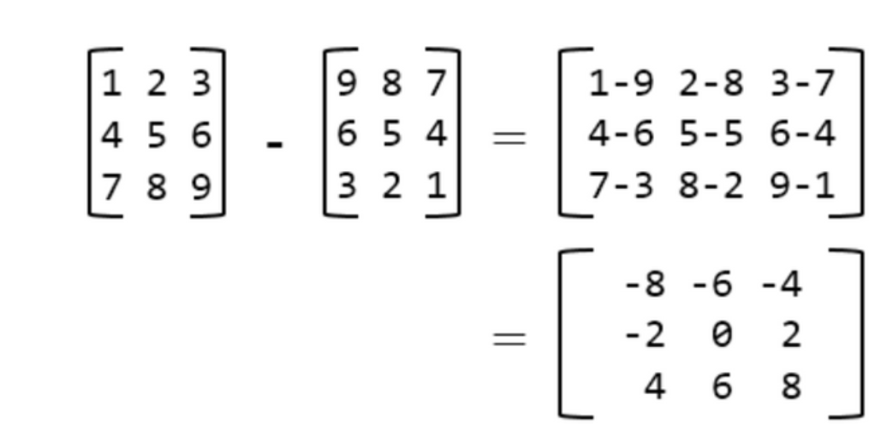
Explanation 2:
[[1, 1]] - [[2, 3]] = [[1 - 2, 1 - 3]] = [[-1, -2]]
CODE:
public class Solution {
public int[][] solve(int[][] A, int[][] B) {
int[][] sub=new int[A.length][A[0].length];
for(int i=0;i<A.length;i++) for(int j=0;j<A[0].length;j++){
sub[i][j]=A[i][j]-B[i][j];
}
return sub;
}
}
Q4. Are Matrices Same ?
Problem Description
You are given two matrices A and B of equal dimensions and you have to check whether two matrices are equal or not.
NOTE: Both matrices are equal if A[i][j] == B[i][j] for all i and j.
Problem Constraints
1 <= A.size(), B.size() <= 1000
1 <= A[i].size(), B[i].size() <= 1000
1 <= A[i][j], B[i][j] <= 1000
A.size() == B.size()
A[i].size() == B[i].size()
Input Format
First argument is 2-D array of integers representing matrix A.
Second argument is 2-D array of integers representing matrix B.
Output Format
Return 1 if both matrices are equal or return 0.
Example Input
Input 1:
A = [[1, 2, 3],
[4, 5, 6],
[7, 8, 9]]
B = [[1, 2, 3],
[4, 5, 6],
[7, 8, 9]]
Input 2:
A = [[1, 2, 3],
[4, 5, 6],
[7, 8, 9]]
B = [[1, 2, 3],
[7, 8, 9],
[4, 5, 6]]
Example Output
Output 1:
1
Output 2:
0
Example Explanation
Explanation 1:
==> Clearly all the elements of both matrices are equal at respective positions.
Explanation 2:
==> Clearly, there are mismatches at (1, 0), (1, 1), (1, 2), (2, 0), (2, 1) and (2, 2).
A = [[1, 2, 3],
[4, 5, 6],
[7, 8, 9]]
B = [[1, 2, 3],
[7, 8, 9],
[4, 5, 6]]
CODE:
public class Solution {
public int solve(int[][] A, int[][] B) {
for(int i=0;i<A.length;i++){
for(int j=0;j<A[0].length;j++){
if(A[i][j]!=B[i][j])
return 0;
}
}
return 1;
}
}
Q5. Print matrix column by column
Problem Description
Given a matrix of N rows and M columns, print it column by column. Firstly print 0th column, then 1st column, 2nd column and so on.
Note: Make sure to receive the matrix input row by row.
Problem Constraints
1 <= N <= 100
1 <= M <= 100
1 <= mat[i][j] <= 10000
Input Format
Two values denoting N and M,
Next N lines contain M space separated integers representing the matrix Mat
Output Format
M lines denoting each column
Note: Ensure there is a space character (' ') at the end of the line.
Example Input
3 4
10 20 30 40
50 60 70 80
90 100 110 120
Example Output
10 50 90
20 60 100
30 70 110
40 80 120
Example Explanation
0th column -> 10 50 90
1st column -> 20 60 100
2nd column -> 30 70 80
3rd column -> 40 80 120
CODE:
import java.lang.*;
import java.util.*;

public class Main {
public static void main(String[] args) {
Scanner sc=new Scanner(System.in);
int N=sc.nextInt(),M=sc.nextInt();
int[][] mat=new int[N][M];
for(int i=0;i<N;i++) for(int j=0;j<M;j++) mat[i][j]=sc.nextInt();

for(int i=0;i<M;i++) {
for(int j=0;j<N;j++){
System.out.print(mat[j][i]+" ");
}
System.out.println();
}

}
}

